# Car Rental System Project

## Deliverable #4

• Ahmed Adel 22-101252

• Ahmed Badr 22-101101

• Amr Azazy 22-101237

• Hazem Amer 21-101105

# Part 1:

|  |  |
| --- | --- |
| **Use Case** | **User Interfaces** |
| Customer Account Creation | Signup Screen  Signup Successful Screen |
| Vehicle Search and Reservation | Home Screen  Vehicle Reservation Screen  Checkout Screen  Order Confirmed Screen |
| Submit Feedback | Feedback Screen Completed Feedback Screen |
| Customer Reservation History Access | Profile Screen  Order History Screen |
| Vehicle Pickup and Identity Verification | Fleet Verification Screen  Fleet Confirmed Screen |
| Vehicle Return and Condition Logging | Same Fleet Verification and Fleet Confirmed Screens |
| Reporting and Analytics Generation | Menu Screen Expanded Menu Screen |

1. The list of User Interfaces for each use case.
2. The menu items in tabular format

|  |  |  |
| --- | --- | --- |
| **Actor** | **Use Case** | **Subsystem** |
| Customer | Customer account creation | User management |
| Customer | Vehicle search and reservation | Vehicle management |
| Customer | Submit feedback | Feedback management |
| Customer | Customer reservation history access | Reservation management |
| Customer Service Staff | Vehicle pickup and identity verification | Reservation management |
| Fleet Manger | Vehicle return and condition logging | Vehicle management |
| Admin | Reporting and analytics generation | Reporting and analytics |

1. Storyboard for each use case
2. **Customer Account Creation**
3. Signup Screen: The customer fills in their information (first name, last name, email, password, license number).
4. Submit Form: User clicks on the "Signup" button.
5. Signup Successful Screen: A success message appears confirming the account creation.
6. Login Screen: when the user press continue on “Signup successful” he navigates to the login screen

**2. Vehicle Search and Reservation**

1. Home Screen: User views available cars and selects one.
2. Vehicle Reservation Screen: User reviews the selected car's details.
3. Checkout Screen: User selects pickup/return dates and confirms the total cost.
4. Order Confirmed Screen: A success message with order number appears.

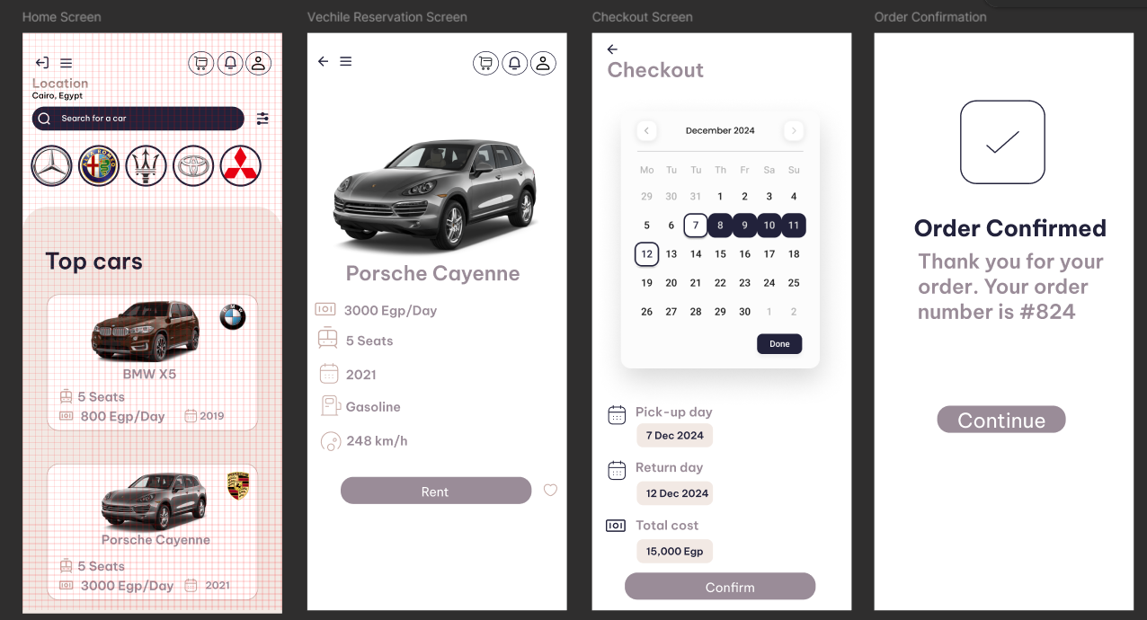

**3. Submit Feedback**

1. Feedback Screen: User provides their feedback and selects a star rating.
2. Submit Form: User clicks "Submit Feedback."
3. Completed Feedback Screen: A confirmation message, "Thanks for the feedback!" appears.

**4. Customer Reservation History Access**

1. Profile Screen: User clicks on "View Order History."
2. Order History Screen: A list of past reservations is displayed with statuses (e.g., pending, canceled).

**5. Vehicle Pickup and Identity Verification**

1. Fleet Verification Screen: User enters order number and license details for verification.
2. Confirm: User clicks "Confirm."
3. Fleet Confirmed Screen: A success message appears instructing the fleet manager to give the car keys.

1. Ui Designs

Figma link: <https://www.figma.com/design/6GFtd04S1y5b22ZqZdXaai/Car-Rental-System?node-id=0-1&t=bMr2XzyAjwEJWVqo-1>

(Each screen’s screenshot is attached in a separate file *“UI Designs” file*)

# Part 2:

* 1. First cut

1-first cut

Step 1: identify classes

1-customer

2-feedback

3-loyalty points

4-fleet

5-vehicle

6-reservation

7-report

8-admin

9-account

Step 2: Determine Attributes and Data Types

1-customer

customerID int (key)

name string

contactInfo string

driverLicense string

2-reservation

reservationID int (key)

rentalPeriod string

rentalQuote float

status string

3-account

accountID int (key)

createdDate string

status string

4-feedback

feedbackID int (key)

comments string

rating int

5- loyalty points

pointsID int (key)

totalPoints int

expirationDate string

6-vehicle

vehicleID int (key)

type string

seatingCapacity int

price float

7-fleet

fleetID int (key)

vehicles list<Vehicle>

8-admin

adminID int (key)

role string

permissions string

9-report

reportID int (key)

reportType string

generatedDate string

Step 3: add methods

1-customer

createAccount()

viewReservation()

modifyAccount()

2- Reservation

createReservation()

modifyReservation()

cancelReservation()

3-account

activeAccount()

deleteAccount()

4- Feedback

submitFeedback()

editFeedback()

deleteFeedback()

5- LoyaltyPoints

adjustPoints()

clearPoints()

6-vehicle

searchVehicle()

updateStatus()

retireVehicle()

7- Fleet

addVehicleToFleet(vehicle)

updateFleetStatus()

8-admin

generateReports()

manageAccounts()

9-report

generate()

view()

* 1. Use cases classification

* 1. CRC

1. A grid of paper with many different forms

   Description automatically generated with medium confidence